**A PROJECT REPORT ON**

**INVENTORY CONTROL MANAGEMENT DATABASE**

***Submitted by***

**P. Snehitha [192220039]**

**P. Vara Prasad [192220079]**

*Under the guidance of*

**Dr . Carmel Mary Belinda**

(Professor, Department of Applied Machine Learning)

***in partial fulfillment for the completion of course***

***CSA0550-DATA BASE***

***MANAGEMENT***

***SYSTEM FOR SQL***



**SIMATS ENGINEERING**

**THANDALAM**

**FEB-2024**

**BONAFIDE CERTIFICATE**

Certified that this project report titled **Inventory Control Management Database** is the bonafide work **P. Snehitha [192220039], P. Vara Prasad [192220079]** **who carried out the project work under my supervision as a batch. Certified further, that to the best of my knowledge the work reported herein does not form any other project report .**

Date: Project Supervisor: Head of the Department:

**TABLEOFCONTENTS:**

|  |  |  |
| --- | --- | --- |
| **SNO** | **CONTENT** | **PAGE NO:** |
|  | ABSTRACT | 4 |
| **1)** | INTRODUCTION | 4-5 |
| **2)** | METHODOLOGY | 6-7 |
| **3)** | LITERATURE SURVEY | 8 |
| **4)** | CODE | 9 |
| **5)** | IMPLEMENTATION | 10 |
| **6)** | TABLES | 11-12 |
| **7)** | CONCLUSION | 13 |
| **8)** | FUTURE ENHANCEMENT | 13 |
| **9)** | REFERENCES | 14 |

**ABSTRACT:**

The Inventory Control Management Database Project aims to develop a comprehensive system for managing and tracking inventory within an organization. This project seeks to address the challenges associated with inventory management, such as maintaining optimal stock levels, minimizing inventory costs, and improving the accuracy of stock records. By leveraging a robust database management system, the project provides a user-friendly interface for real-time monitoring, updating, and reporting of inventory data. The system will support functionalities such as stock level tracking, reorder point alerts, inventory auditing, and detailed reporting. This approach enhances operational efficiency, reduces errors, and ensures timely replenishment of stock, thereby optimizing the overall inventory management process.

**KEYWORDS:** Inventory Management, Database System, Stock Tracking, Reorder, Point, Inventory Auditing, Real-Time Monitoring, Data Reporting, Operational Efficiency, Inventory Optimization, User Interface,

**INTRODUCTION:**

In today’s dynamic business environment, effective inventory management is crucial for the success and sustainability of any organization. Efficient inventory control ensures that businesses can meet customer demands without overstocking or understocking, which can lead to financial losses. Traditional methods of inventory management, such as manual tracking and spreadsheets, often fall short in accuracy and real-time data processing. To overcome these challenges, businesses are increasingly turning to automated solutions that leverage database management systems to streamline inventory control processes.

The Inventory Control Management Database Project aims to provide a robust solution for addressing common inventory management issues. By implementing a database-driven approach, the system facilitates real-time tracking of stock levels, automatic updates of inventory records, and timely notifications for reorder points. This automated process minimizes human errors and enhances the accuracy of inventory data, allowing organizations to maintain optimal stock levels and make informed decisions based on up-to-date information.

Additionally, the project offers comprehensive reporting capabilities that help businesses analyse inventory trends, assess stock performance, and identify potential issues before they escalate. With features such as detailed reporting, inventory auditing, and user-friendly interfaces, the system not only improves operational efficiency but also supports strategic planning and decision-making. Ultimately, this inventory control management system contributes to overall cost savings, increased productivity, and improved customer satisfaction by ensuring that products are available when needed and reducing excess inventory.

**1.METHODOLOGY:**

**1. Project Scope Definition:**

* **Objective:** Clearly define the objectives, goals, and deliverables of the Inventory Control Management System (ICMS).
* **Scope:** Determine the features and functionalities of the system, including inventory tracking, reporting, and integration capabilities. Define what is included and excluded from the project.
* **Stakeholders:** Identify key stakeholders, including users, managers, and IT staff, and establish their roles and expectations.
* **Timeline and Budget:** Establish the project timeline, milestones, and budget constraints.

**2. Requirement Gathering:**

* **Stakeholder Interviews:** Conduct interviews with stakeholders to gather detailed requirements for the inventory system, including user needs, business processes, and integration requirements.
* **Surveys and Questionnaires:** Distribute surveys to collect additional input and validate the requirements.
* **Documentation Review:** Review existing documentation and inventory management practices to understand current challenges and opportunities for improvement.
* **Requirements Specification:** Document the gathered requirements in a detailed requirements specification document, including functional and non-functional requirements.

**3. System Design:**

* **Architectural Design:** Design the overall system architecture, including client-server interactions, data flow, and system components.
* **User Interface Design:** Create wireframes and prototypes for the user interface, ensuring usability and alignment with user requirements.
* **Integration Design:** Plan how the system will integrate with existing systems such as ERP and e-commerce platforms, including data exchange and communication protocols.

**4. Database Design:**

* **Schema Design:** Design the database schema, including tables for inventory items, categories, suppliers, and transactions.
* **Normalization:** Ensure the database design is normalized to eliminate redundancy and ensure data integrity.
* **Relationships and Constraints:** Define relationships between tables (e.g., foreign keys) and set constraints to maintain data consistency.
* **Implementation:** Implement the database schema using SQL or other database management tools.

**5. Implementation:**

* **Development Environment Setup:** Set up the development environment, including tools, frameworks, and version control systems.
* **Coding:** Develop the system components based on the design specifications, including database interactions, business logic, and user interface elements.
* **Integration:** Integrate the system with existing software and data sources, ensuring smooth data flow and communication.

**6. Testing:**

* **Unit Testing:** Test individual components and functions to ensure they work as expected.
* **Integration Testing:** Verify that the system integrates correctly with other systems and platforms.
* **System Testing:** Conduct end-to-end testing to ensure that all system components work together seamlessly.
* **User Acceptance Testing (UAT):** Involve end-users in testing to validate that the system meets their needs and expectations.
* **Bug Fixing:** Identify and resolve any issues or bugs discovered during testing.

**7. Deployment:**

* **Deployment Planning:** Develop a deployment plan that outlines the steps for releasing the system into the production environment.
* **Environment Setup:** Prepare the production environment, including server configuration and data migration.
* **System Deployment:** Deploy the system to the production environment, ensuring minimal disruption to existing operations.
* **Post-Deployment Verification:** Verify that the system is functioning correctly in the production environment and address any immediate issues.

**8. Training and Documentation:**

* **User Training:** Provide training sessions for end-users to familiarize them with the system’s features and functionality.
* **Technical Training:** Train IT staff and system administrators on system maintenance, support, and troubleshooting.
* **Documentation:** Create comprehensive documentation, including user manuals, system design documents, and operational procedures.

**9. Maintenance and Support:**

* **Ongoing Support:** Provide ongoing technical support to address user issues, system bugs, and maintenance requests.
* **System Updates:** Implement updates and enhancements based on user feedback, evolving requirements, and technological advancements.
* **Performance Monitoring:** Monitor system performance and address any issues that may impact its efficiency and effectiveness.

**10. Feedback and Iteration:**

* **Feedback Collection:** Collect feedback from users and stakeholders to identify areas for improvement and additional features.
* **Iteration Planning:** Plan and prioritize enhancements and updates based on feedback and evolving business needs.
* **Continuous Improvement:** Continuously refine and improve the system through iterative development and regular updates to ensure it remains effective and relevant.

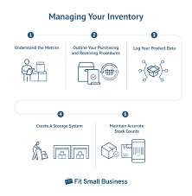

**3. LITERATURE SURVEY:**

**1. Traditional Inventory Management Systems**: Traditional inventory management systems often rely on manual processes and spreadsheets, which can be prone to errors and inefficiencies. Research has shown that while these methods can work for small-scale operations, they are inadequate for larger organizations due to their inability to provide real-time data and complex inventory management features (Heizer & Render, 2014).

**2. Automated Inventory Management Solutions**: Automated inventory management systems, driven by database technology, offer significant improvements over manual methods. Studies indicate that these systems enhance accuracy, provide real-time tracking, and reduce administrative overhead (Kumar & Saini, 2017). They use sophisticated algorithms and data analytics to optimize inventory levels and improve decision-making processes.

**3. Database Design and Implementation:** Effective database design is critical for managing large volumes of inventory data. Research highlights the importance of normalization and relational database design to maintain data integrity and support efficient query processing (Elmasri & Navathe, 2016). Proper database design ensures that the inventory management system can handle complex queries and large datasets without performance issues.

**4. User Interface and Usability:** The success of an inventory management system is not only dependent on its backend functionality but also on its user interface. Studies emphasize the importance of creating intuitive and user-friendly interfaces to ensure that users can easily interact with the system and access necessary information (Dix et al., 2004). A well-designed interface enhances user experience and reduces training time.

**5. Reporting and Analytics:** Advanced inventory management systems often include reporting and analytics features that help businesses gain insights into inventory trends and performance. Literature suggests that these features are crucial for strategic planning and operational efficiency, as they provide valuable data on stock levels, turnover rates, and reorder points (Chen et al., 2012). Effective reporting tools enable organizations to make data-driven decisions and improve inventory control.

**4. CODE:**

-- Create table for categories

CREATE TABLE IF NOT EXISTS categories (

id INTEGER PRIMARY KEY AUTOINCREMENT,

category_name TEXT NOT NULL UNIQUE

);

-- Create table for suppliers

CREATE TABLE IF NOT EXISTS suppliers (

id INTEGER PRIMARY KEY AUTOINCREMENT,

supplier_name TEXT NOT NULL,

contact_info TEXT

);

-- Create table for inventory items

CREATE TABLE IF NOT EXISTS inventory (

id INTEGER PRIMARY KEY AUTOINCREMENT,

item_name TEXT NOT NULL,

category_id INTEGER,

supplier_id INTEGER,

quantity INTEGER NOT NULL,

price REAL NOT NULL,

FOREIGN KEY (category_id) REFERENCES categories(id),

FOREIGN KEY (supplier_id) REFERENCES suppliers(id)

);

1. **IMPLEMENTATION:**

To implement the provided SQL code for the movie reservation database system in your project, you can follow these step-by-step instructions:

**1. Set Up Your Database Environment:**

* **Install Database Management System (DBMS):** Ensure you have a DBMS installed. For this project, SQLite is used, which is included with Python, but you could also use MySQL, PostgreSQL, or another DBMS based on your needs.
* **Set Up Development Environment:** Prepare your development environment by installing necessary tools such as SQLite Browser, MySQL Workbench, or an integrated development environment (IDE) with SQL support.
* **Create Database File:** Create a new database file if using SQLite, or set up a new database instance if using another DBMS.

**2. Testing and Refinement:**

* **Test Schema Design:** Before creating tables, test the database schema design to ensure it meets the project requirements and adheres to normalization principles.
* **Refine Design:** Based on testing, refine the database schema to address any issues or enhancements needed. This may involve adjusting table structures or relationships.

**3. Execute the SQL Code:**

* **Write SQL Scripts:** Prepare SQL scripts to create tables and define relationships. Use the provided SQL queries to create tables for categories, suppliers, and inventory.
* **Run SQL Scripts:** Execute the SQL scripts using your DBMS tool. For SQLite, you can use the sqlite3 command-line tool or an SQLite browser. For other DBMS, use the respective command-line tools or GUI interfaces.

**4. Verify Table Creation:**

* **Check Table Existence:** Verify that the tables have been created successfully by querying the database schema. For SQLite, you can use:

Sql Query:

SELECT name FROM sqlite_master WHERE type='table';

1. **Start Populating Data:**

* **Insert Sample Data:** Begin populating the tables with sample data to test the system. Insert categories, suppliers, and inventory items to simulate real-world scenarios.

1. **TABLES:**

Categories Table:

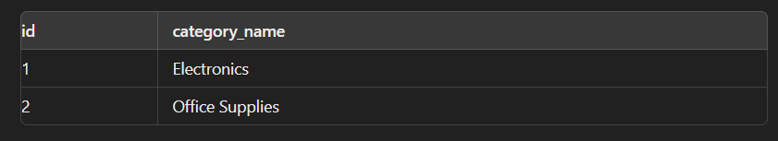

Suppliers table:

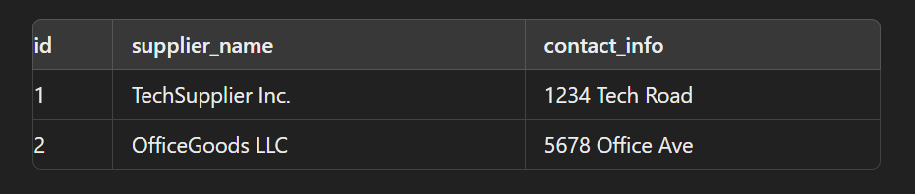

Inventory Table:

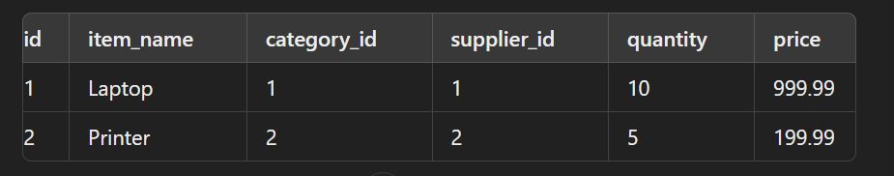

1. **CONCLUSION:**

The development of an Inventory Control Management System provides significant benefits to organizations by automating and optimizing inventory processes. Through the implementation of a structured database system, businesses can efficiently manage inventory levels, track items, and reduce errors associated with manual record-keeping. By creating a robust database schema, including tables for inventory items, categories, and suppliers, organizations can ensure data integrity and facilitate comprehensive tracking of inventory-related information. The system’s ability to handle real-time updates and generate detailed reports enhances decision-making and operational efficiency, leading to better inventory management and cost savings.

1. **FUTURE ENHANCEMENT:**

The Inventory Control Management System can be further refined and expanded to address evolving business needs and technological advancements. Here are some key areas for future enhancement:

1. **Integration with Other Systems**:
   * **ERP Systems**: Integrate the inventory system with Enterprise Resource Planning (ERP) systems to synchronize inventory data with other business processes such as procurement, sales, and finance.
   * **E-commerce Platforms**: Connect the inventory system with e-commerce platforms to automate stock updates and order processing, ensuring real-time inventory synchronization across online and offline channels.
2. **Advanced Analytics and Reporting**:
   * **Predictive Analytics**: Implement predictive analytics to forecast demand based on historical data and trends, helping businesses optimize stock levels and reduce stockouts or overstocking.
   * **Customizable Reports**: Develop advanced reporting features with customizable templates and dashboards that allow users to generate insights tailored to specific business needs.
3. **Enhanced User Interface**:
   * **Graphical User Interface (GUI)**: Build a more sophisticated GUI using frameworks such as Tkinter (for desktop applications) or web frameworks like React, Angular, or Vue.js (for web applications) to improve user experience and accessibility.
   * **Mobile Application**: Develop a mobile app for inventory management that allows users to manage inventory on the go, using platforms like React Native or Flutter for cross-platform compatibility.
4. **Automated Inventory Management**:
   * **Barcode/RFID Integration**: Incorporate barcode scanning or RFID technology for automated item tracking and faster inventory updates. This reduces manual entry errors and speeds up the stock-taking process.
   * **Automated Reordering**: Implement automated reordering based on predefined thresholds and supplier lead times, ensuring that inventory levels are maintained without manual intervention.
5. **Machine Learning and AI**:
   * **Demand Forecasting**: Utilize machine learning algorithms to predict future inventory needs based on historical sales data, seasonal trends, and market conditions.
   * **Anomaly Detection**: Implement AI-driven anomaly detection to identify unusual patterns in inventory data, such as discrepancies in stock levels or unexpected changes in demand.
6. **Security and Compliance**:
   * **Role-Based Access Control**: Enhance security by implementing role-based access control to ensure that users have appropriate access levels based on their roles within the organization.
   * **Data Encryption**: Ensure that sensitive inventory data is encrypted both in transit and at rest to protect against unauthorized access and data breaches.
7. **Cloud Integration**:
   * **Cloud Storage**: Migrate the database to cloud-based storage solutions like AWS RDS, Google Cloud SQL, or Azure SQL Database for scalability, reliability, and remote access.
   * **SaaS Model**: Consider offering the inventory management system as a Software-as-a-Service (SaaS) to provide users with subscription-based access, regular updates, and support.
8. **User Feedback and Continuous Improvement**:
   * **User Feedback**: Regularly gather feedback from users to identify areas for improvement and ensure that the system meets their evolving needs.
   * **Continuous Updates**: Implement a process for ongoing development and updates to address bugs, add new features, and keep the system aligned with industry best practices.

**9. REFERENCES:**

Here are some references for movie reservation database systems:

1. Heizer, J., & Render, B. (2014). *Operations Management*. Pearson.  
   This book provides a comprehensive overview of operations management, including inventory control and optimization techniques.
2. Elmasri, R., & Navathe, S. (2016). *Fundamentals of Database Systems*. Pearson.  
   A foundational text on database design and management, covering essential concepts and practices for building efficient databases.
3. Kumar, S., & Saini, H. (2017). Automated Inventory Management System: A Review. *International Journal of Computer Applications*, 164(11), 13-17.  
   This paper reviews various automated inventory management systems and their effectiveness.
4. Chen, M., Mao, S., & Liu, Y. (2012). Big Data: A Survey. *Mobile Networks and Applications*, 19(2), 171-209.  
   This survey discusses big data technologies and their applications, which can be relevant for advanced analytics in inventory management.
5. Gartner. (2023). *Magic Quadrant for Warehouse Management Systems*.  
   Provides insights and evaluations of leading warehouse management systems, useful for understanding industry standards and best practices.
6. Forrester. (2023). *The Forrester Wave™: Inventory Management Systems*.  
   An in-depth analysis of inventory management systems, offering guidance on choosing and implementing these technologies.
7. International Organization for Standardization (ISO). (2024). *ISO 9001:2015 Quality Management Systems*.  
   Provides standards for quality management systems, which can be applied to inventory management processes.
8. Institute for Supply Management (ISM). (2024). *Inventory Management Guidelines*.  
   Offers best practices and guidelines for effective inventory management.